STEPS TO JOIN
1) COMPLETE 2022-23 Provisional Member Interest & Application.
USE QR CODE BELOW OR go to jlbr.org > select Join JLBR > select becoming a member> scroll down to the complete initial application link.
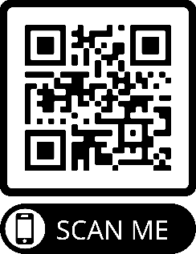

Once completed you have a username and password, which you will use to sign in to complete the remaining steps. Sign in by going to jlbr.org and select members in the top right corner.
2) Pay $50 Application Fee (one time fee)
3) Complete a Background Check (See Background check direction page)
4) Pay $167 Annual Dues

THE SOONER YOU COMPLETE ALL THE STEPS, THE SOONER YOU WILL BE A JUNIOR LEAGUE PROVISIONAL MEMBER AND CAN START PARTICIPATING IN MEMBER EVENTS AND VOLUNTEER OPPORTUNITIES.
YOU MUST COMPLETE ALL STEPS BY September 2nd TO JOIN THIS YEAR.

